Rules for keeping your
information private and safe

Mencap Privacy Policy

V1

What is in this booklet

 | Page
About this booklet | 3
What information might we have about you? | 4
Why we keep information about you and other people | 5
How we can get information about you | 6
How we keep your information private and safe | 10
What to do if you are not happy with this | 11

About this booklet

We are Mencap.

By Mencap we mean:
- Mencap
- Golden Lane Housing
- Mencap Trust Company Limited

This booklet is about:

- Information we may have about you

- How we use the information for our work

- How we keep your information private and safe

There are new rules about how we must keep your information.

The new rules are called the General Data Protection Regulation.
The rules started in May 2018.

What information might we have about you?

Sometimes we might have some information about you.

For example, if you use our website, use our services or support our work.

We might have information like:

- Your name, address, age, phone number or email address

- The area you live in

- Health information if you take part in our sports events

We have this information because:

- You share it with us
- You share it with other organisations that help us with our work

Why we keep information about you and other people

Keeping information about people helps us do much better work.

For example, information about you and other people can help us know:

- What sort of people might support us or use our services
For example, what age people are and where they might live

- How people may want to support us

- What information you want from us

- The best way to give you information and keep in touch

How we can get information about you

1. You might share information with us

For example, you might give us information about you when you:

- Take part in our events

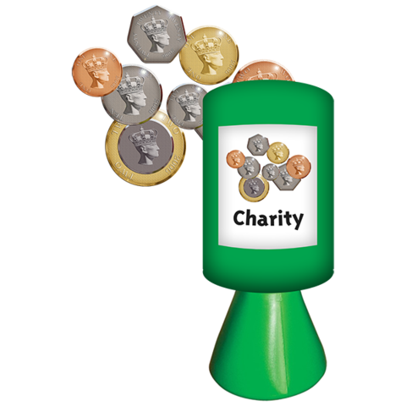
- Ask us for support

- Sign up to our website

- Give us money or support our work in other ways

2. You might share information with other organisations

Some organisations help us with our work or do work for us.

For example, they may help us raise money.
These organisations might take some information from you and give it to us.

For example, this might happen if you:

- Give us some money by phone

- Give us money on a website like JustGiving or Virgin Money Giving

- Take part in an event like the London Marathon

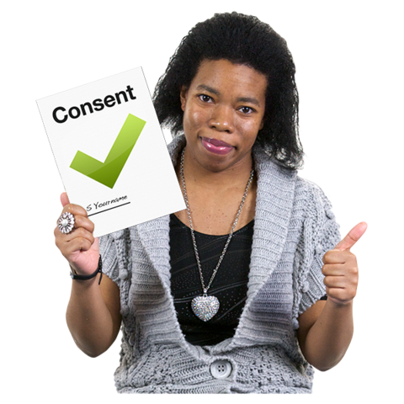
The organisations can only give us information about you if you agree first.

It is best to check the organisation’s rules about how they use your information.

The rules are often called a privacy policy.

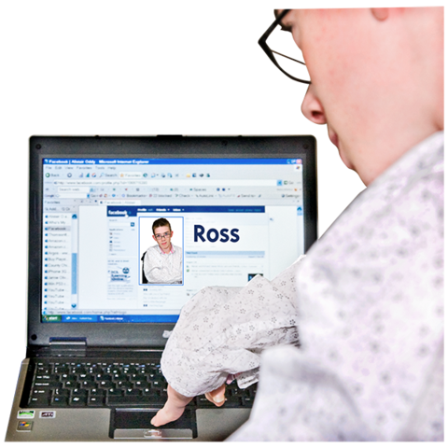
3. We might get information about you from our website and other places

We might get information about you if you use social media, like Twitter, Facebook and WhatsApp.

We can do this if:

- You agree first

- You write something on our Facebook page or other social media pages

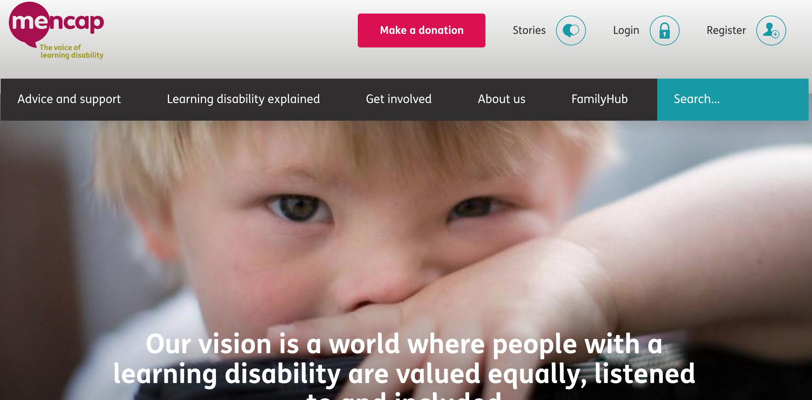
Our website

When you use our website, we can get some information like:

- What kind of computer or phone you are using

- What web pages you look at
when you look on our
website
- The area you are in when you look at our website (but not where you live)

This information helps us know how to make our website better.

We also use things called cookies.

Most websites use cookies.

They help websites remember information about you.

For example, when you fill in information on our website it may remember the information next time you visit the website.

Your parents or carers

We may get some information from your parents or carers if you are under 16 years old.

Information that the public can see

We may use some information that the public can see about you or the area you live in.
For example, addresses or information about how much people near you earn.

How we keep your information private and safe

We are in charge of your information at all times.

We will:

- Keep all information about you safe.
For example, information on our websites and computers.

We follow laws and rules about this

- Tell you when we have information about you and how we will use it

- Keep the information only as long as we need it

- Ask you before we share your information (unless there is a big problem and we have to tell the police)

We will:

- Use your information in a good and fair way at all times

- Make sure our staff and organisations we work with know how to keep your information safe

What to do if you are not happy with this

You can say if you are not happy with
the information we have about you or how we use it.

For example, you can:

- Ask us to stop sending you emails or letters about our work.

You can click on the link in the email called unsubscribe to do this.

You can:

- Ask us for a copy of the information we have about you
- Ask us to change any wrong information about you

Ask us to delete (get rid of) information we have about you if you think there is a good reason.

We will see if we can do this or not.

- Ask us to stop using your information for our work.

For example, our work to raise money or to find out who supports us.

We will still keep your information if so. But we will stop using it for our work.

To change the information you get from us

You can set up an account on the Mencap website.

Or phone us on 0845 077 0777

Or email supportercare@mencap.org.uk

Making a complaint

You can complain to us if you think we have used your information in the wrong way.

If you want to do this, please write to:

Data Protection Officer
123 Golden Lane
London EC1Y 0RT

Or email: dpo@mencap.org.uk

Pictures by Photosymbols

